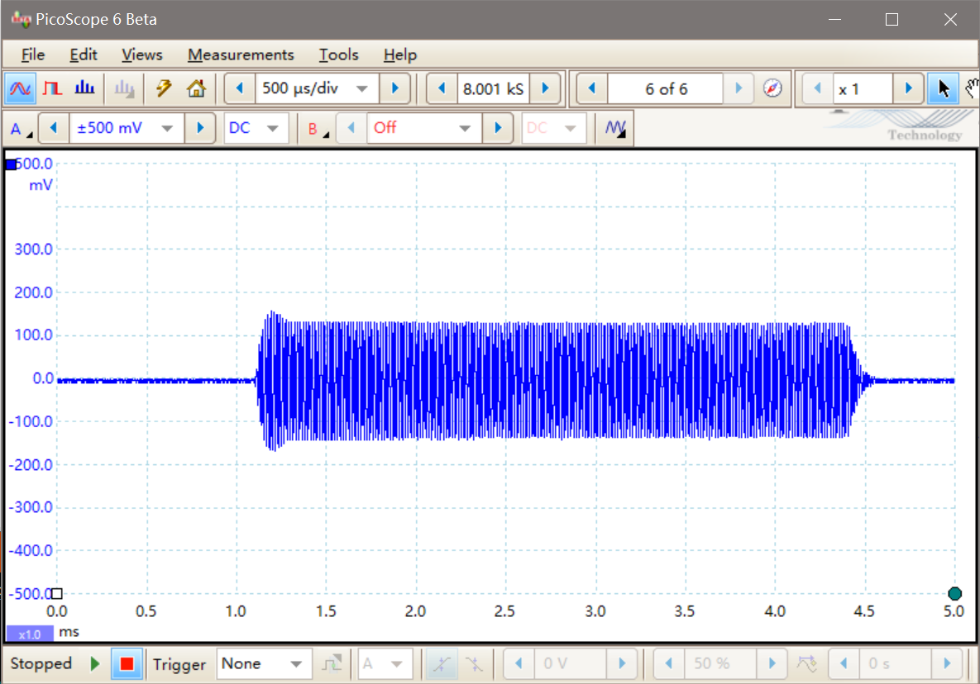

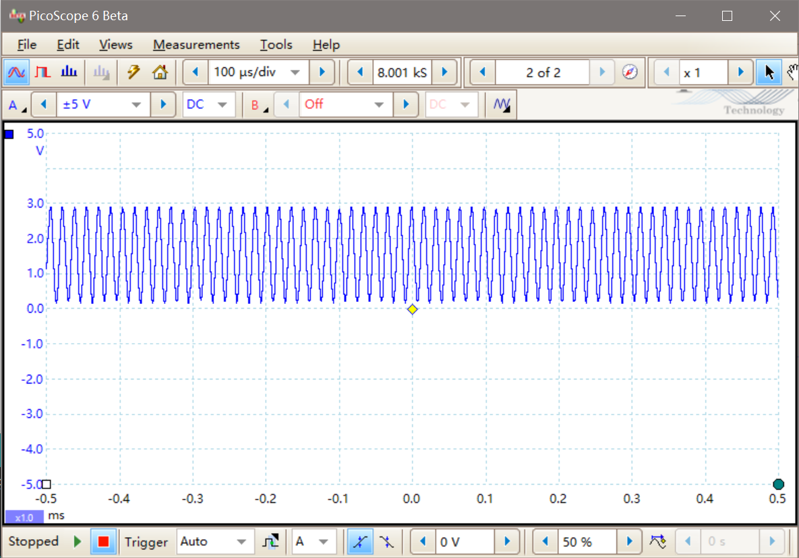

In order to demodulate the signals, an envelope demodulator is built. A sketch of the circuit is shown below. This envelope demodulator is capable to demodulate signals with either 61kHz or 89 kHz carrier frequencies.



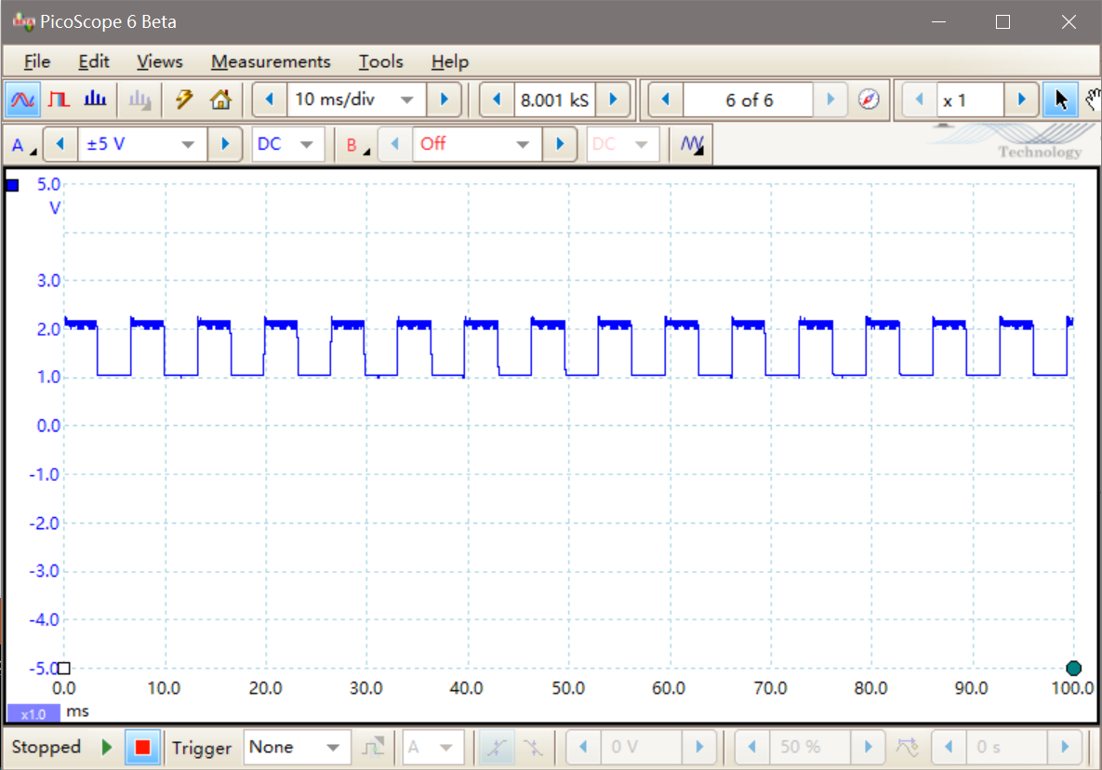

After demodulation, a pulse signal with amplitude 2-3V could be detected, and its frequency was either 151 Hz or 240 Hz, according to the type of mineral. However, the microcontroller works the best detecting signals with a range of 0-5V. So, a Schmitt trigger was built to enlarge this range.

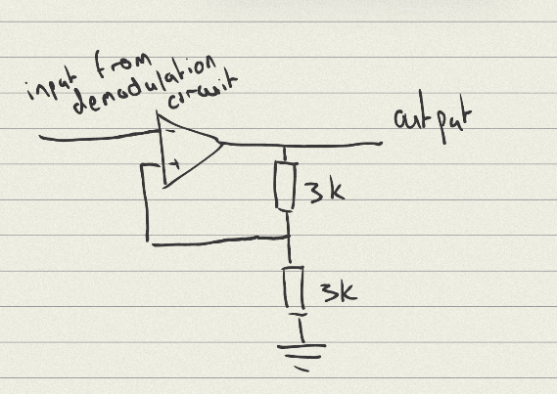

If the input rises then output would rise to its maximum value (5V), and if input decreases the output would reduce to minimum (0V). Because the output is a digital pulse signal, any noise would be filtered as well.

The following is an example of the final waveform that would be received by the microcontroller’s input port.

